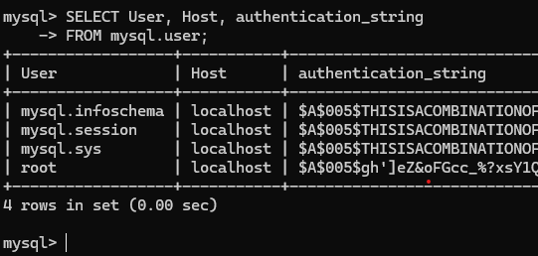
Johnny Vogt

Running this snippet
SELECT User, Host, Password,
FROM mysql.user;
didn’t work for me. Seeing as the intent was to show that I had it installed and logged in, I used “authentication_string”, because mySQL prevents us from viewing “password”.

